
Republic of Yemen
Ministry of Higher Education & Scientific Research
Taiz University
Faculty of Engineering
Software Engineering Dept. – 2nd Level

ISKAN FOR REAL ESTATE MANAGEMENT SYSTEM

SUPERVISED BY :
Dr.MUJEEB AL-SABAEI.
PREPARED BY :
MOHANED GAMEEL ALYOUSFI
TAWHIB MOHAMMED ALYOUSFI
AMR ABDULLAH ALAMRI

- Project Introduction 2
2. Database Introduction: 2
3. Business rules: 2
4. Functional Requirements: 2
5. Non-functional requirements 2
6. Analysis Summary Table 2
7. Entity Relationship Diagram 2
8. Enhanced Entity relation Diagram 2

Project Introduction
This project was initiated in response to the significant lack of organization in the real estate market in Yemen, where individuals often face difficulties when searching for apartments or houses. In many cases, they are forced to rely on brokers or unverified advertisements, which reduces trust and increases the risk of fraud
For this reason, we decided to develop a system called Iskan, which focuses on managing the processes of selling, buying, and renting real estate properties in a structured and systematic manner.
The system is not limited to displaying property images only rather, it is a fully integrated system built using Object-Oriented Programming (OOP) principles, which ensures flexibility, scalability, and ease of future development.
In addition, the system relies on a robust database management system to securely store data, protect user rights, and organize all real estate-related information efficiently.
The core idea of the project is to provide a centralized management platform that governs the interaction between owners and seekers. Unlike traditional listing sites, Iskan acts as a workflow controller where communication and bookings are managed through an internal request-approval cycle, ensuring privacy and serious engagement before disclosing sensitive contact information.

Database Introduction:
We developed an integrated Oracle database designed to ensure data integrity and completely eliminate booking conflicts. Special attention was given to precise relational modeling between tables to regulate access rights while enhancing query performance, delivering a smooth and instant search experience for users.
Our objective goes beyond simple data storage we aim to transform raw data into an intelligent and reliable system that actively supports informed decision-making in the real estate market

Business rules:
- Price Rule: Property prices must be positive zero or negative values are not allowed
- Status Rule: Booking requests cannot be submitted for properties that are already rented or sold
- Privacy Rule: Property owners' direct contact information (phone numbers) is hidden by default and only becomes visible to the tenant after the owner approves their formal booking request.
- Uniqueness Rule: Phone numbers and email addresses must be unique and cannot be associated with multiple accounts
- Deletion Rule: When a user is deleted, all properties linked to that user are automatically removed or archived
- Communication Rule: Initial inquiries and booking interests must be processed through the system's "Request" feature to maintain a documented history of transactions

Functional Requirements:
- ​Account Management: The system enables registration, login, and profile modification for both landlords (owners) and tenants
- ​Property Management: The system allows landlords to add new properties, edit their details, or delete them
- ​Advanced Search: The system facilitates property searches based on city, neighborhood, price range, and property type
- ​View Details: The system displays a dedicated page for each property featuring images, a full description, and location
- Request Management: Tenants can submit formal digital requests to express interest in a property without seeing the owner's private number.
- Owner Decision Making: Owners can review tenant requests and choose to "Approve" or "Reject" them through their private dashboard.
- Automated Contact Release: Upon approval, the system dynamically enables the "Contact Owner" button (WhatsApp API), allowing both parties to finalize the deal securely.

Non-functional requirements
- Security: Ensure passwords are encrypted and owners’ contact information is fully protected.
- Performance: Search results should load in under 3 seconds for a smooth user experience.
- Reliability: Guarantee data is safely stored and remains intact even during connection interruptions.
- Usability: Provide a clean, intuitive interface that is easy to navigate, especially on mobile devices.
- Maintainability: Write clean, well-structured code that can be easily updated or modified in the future

Analysis Summary Table

- Owners table………………………………………
Constraints | Attribute Description | Data Type (SQL) | Attribute Name | Entity Description | Entity Name
PK  Not Null | A unique identifier assigned to each owner in the system | int | Owner_id | The owners entity represents the property owners registered | owners
Unique  Not Null | The full name of the owner as entered in the system | Varcher(30) | ​Owner_name
Not Null | The contact phone number of the owner | int | ​Owner_phone
Nullable | The residential address of the owner | Varchar(20) | Owner_addres
Not Null | The password associated with the owners account | int | Owners_password

B. Location table………………………………

Constraints | Attribute Description | Data Type (SQL) | Attribute Name | Entity Description | Entity Name
PK  Not Null | Unique identifier for location. | int | Location_id | Stores standardized cities and districts | Location
Unique  Not Null | City name | Varchar(50) | ​Location_city
Not Null | Neighborhood name. | Varchar(50) | ​Location_district

Constraints | Attribute Description | Data Type (SQL) | Attribute Name | Entity Description | Entity Name
PK  Not Null | Unique identifier for category | int | categories_id | Classification of property types. | Categories
Unique  Not Null | Type (Apartment  Villa Land) | Varchar(50) | ​ categories_name

- Category table ………………………………….

Constraints | Attribute Description | Data Type (SQL) | Attribute Name | Entity Description | Entity Name
PK  Not Null | Unique identifier for property. | int | Prop_id | Stores details of the real estate listing. | property
FK (Ref:ownrs) | The user who owns this property. | int | ownrs_id
FK (Ref: Category ) | The type of the property. | int | ​Category_id
FK (Ref: Locations) | Where the property is located. | int | Locations_id
Not Null | Short ad title | Varchar(100) | Property_ title
Nullable | Full details of the property | text | Property_description
Not Null | Rent or Sale price. | DECIMAL(15,2) | ​Property_Price
Not Null | Area in sq meters or Libnah. | DOUBLE | Property_Space
Nullable | Number of rooms (if applicable) | Int | Room_count
Default Available | Available Rented Sold | VARCHAR(20) | Property_status
Default Current_Time | When the ad was posted | DATETIME | Created_data
- Property table ……………………………………

- images table …………………………….

Constraints | Attribute Description | Data Type (SQL) | Attribute Name | Entity Description | Entity Name
PK, Not Null | Unique identifier for the image | int | Images_id | Stores paths to property images. | Images
FK (Ref: Properties) | The property this image belongs to. | int | ​Property_id
Not Null | URL or file path on server. | Varchar(200) | ​Image_path

Constraints | Attribute Description | Data Type (SQL) | Attribute Name | Entity Description | Entity Name
PK, Not Null | Unique identifier for the request. | int | Bookig_id | Manages the interaction between tenants and owners by handling the request-approval cycle and controlling the visibility of contact data | bookings
FK (Ref: Properties) | The requested property. | Int | ​Property_id
FK (Ref:tenant) | The user making the request | Int | Tenant_id
Not Null | Date of the request. | DATETIME | Bokings_data
Default 'Pending | Pending Approved Rejected | VARCHAR(20) | Bokings _status
Nullable | Note from tenant to owner | TEXT | Bokings_message

F.bookings table ………………………………………………

- favorites table…………………………… G

Constraints | Attribute Description | Data Type (SQL) | Attribute Name | Entity Description | Entity Name
PK  Not Null | Unique identifier for the favorite record | int | Favorite_id | Stores properties liked by users. | Favorite
FK (Ref:onwers) | The user who liked the property. | int | tenant_id
FK (Ref: Properties) | The property being liked. | int | ​Property_id
Default Current_Time | When it was added to favorites | datetime | ​Added_date

H.Tenants table…………………………………………………….
Entity  Name | Entity  Description | Attribute  Name | Data Type  (SQL) | Attribute  Description | Constraints
Tenants | This entity represents the tenants registered in the system | Tenants_id | int | A unique identier assigned to each tenant | PK  Not Null
 |  | Tenants_phone | int | Stores the tenants phone number | Not Null
 |  | Tenants_address | VARACHER(20) | Stires the residential address of the tenant | Nullabl
 |  | Tenants_password | int | Stores the tenants account password used | Not null
 |  | Tenants_name | VARECHER(30) | Stores the full name of the tenant | Unique not null

Entity Relationship Diagram
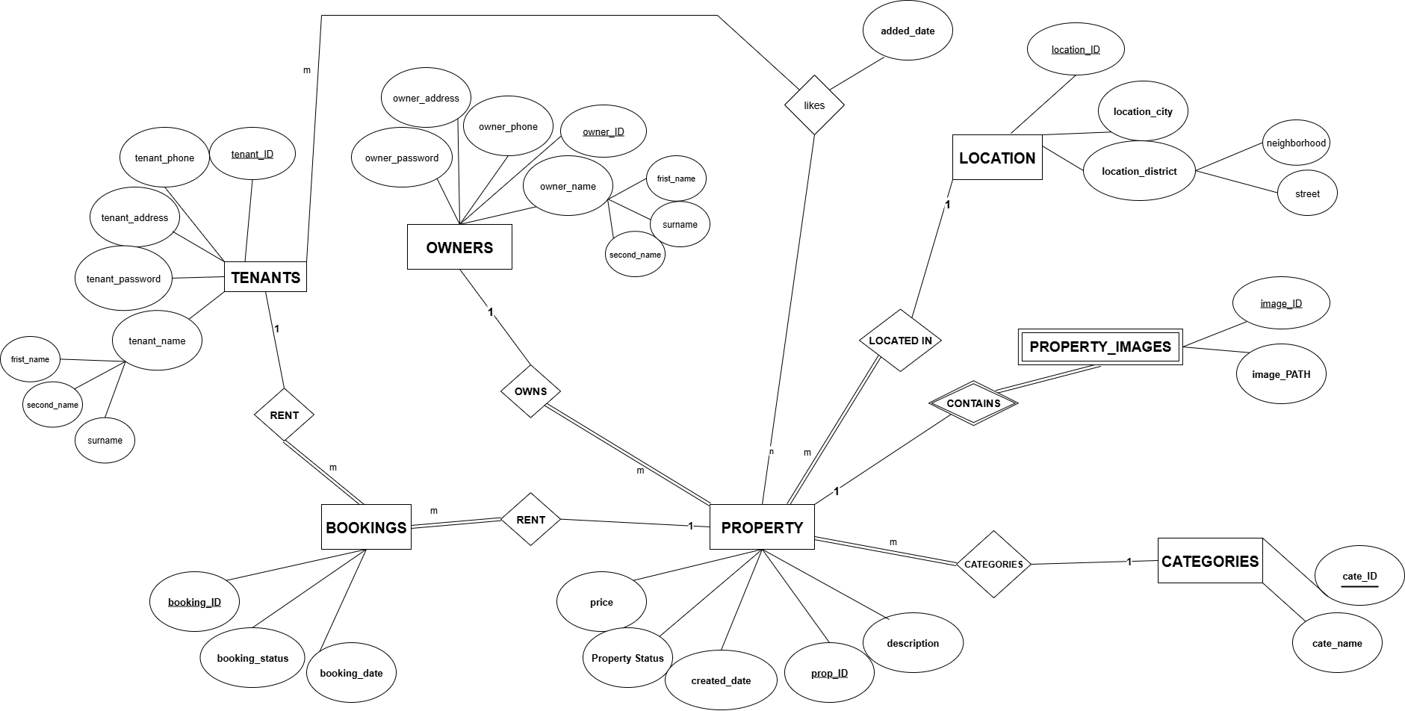

Enhanced Entity relation Diagram
